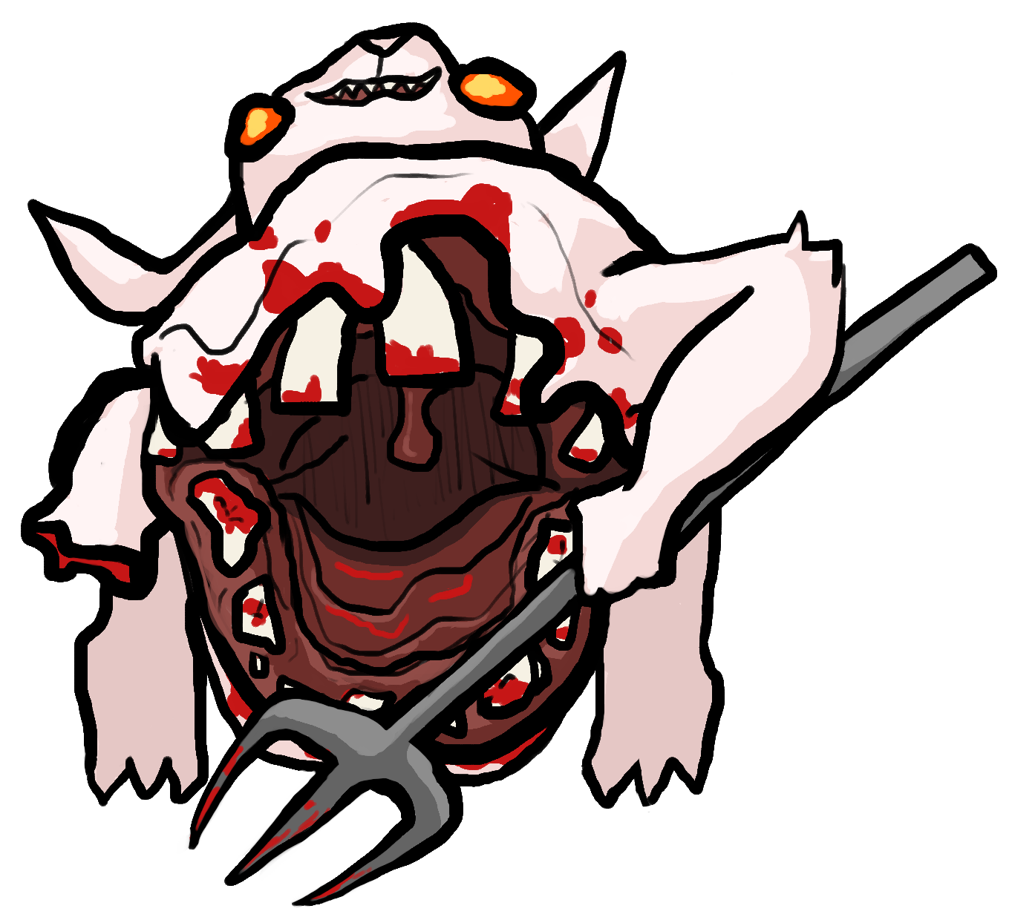**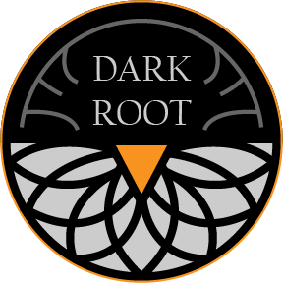****Carrot Quest: The Root of Evil**

*Save Bunnyville from the Carrot Curse!*

**Mow down a variety of monstrously mutated enemies with your revolver as you investigate the source of the Carrot Curse. Find new equipment and abilities with each new area explored!

Navigate strange ruins from a forgotten age, make powerful allies, and find the ultimate Carrot Cannon to wipe out your foes. What dark secrets lie underneath Bunnyville?

● Terraform levels with the burrow technique to get the jump on enemies!

● Fight your way through hordes of mutated wildlife as you venture through Bunnyville.

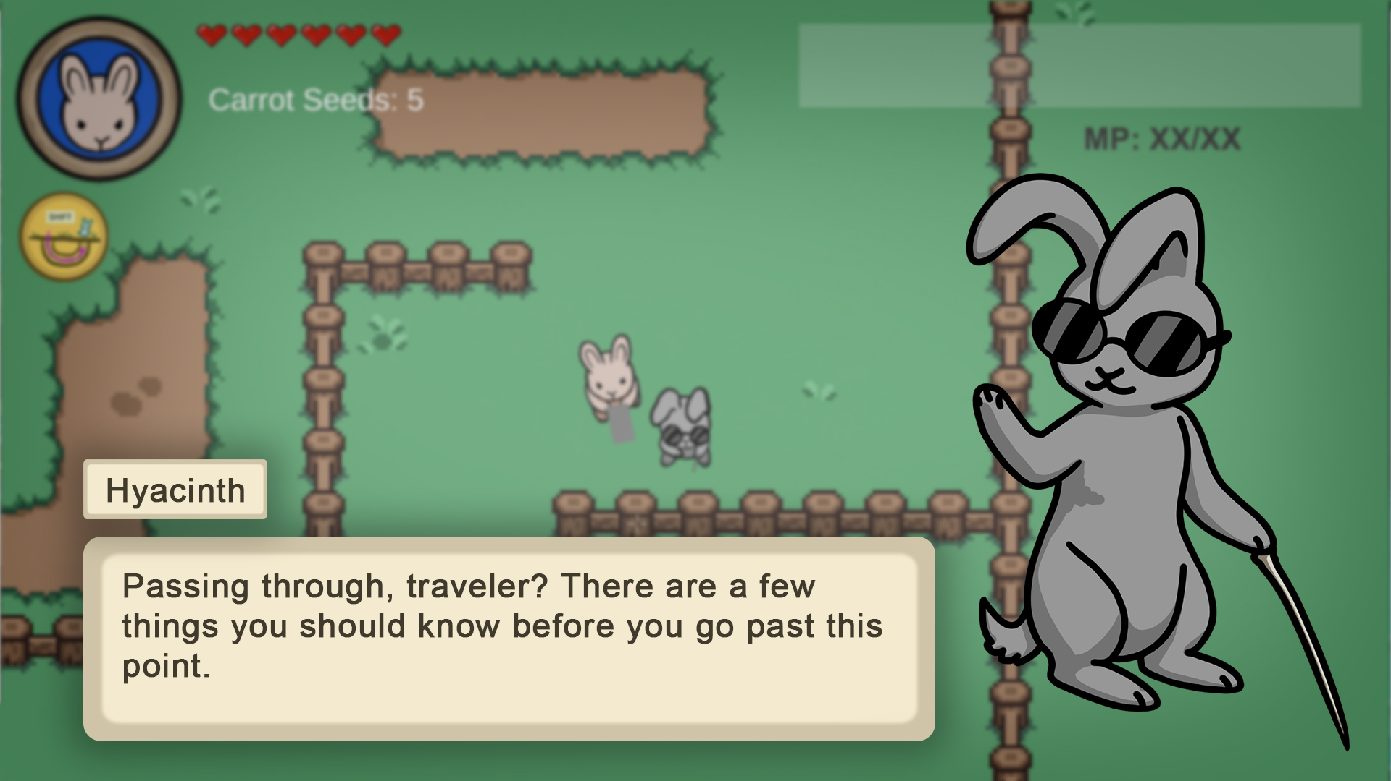**● Solve mysteries and build bonds with NPCs who have secrets of their own.